Practice Problems
UNIT-1
- Design the RE for the language accepting all combinations of a’s except the null string over ∑={a}
- Design the RE for the language containing all the strings containing any number of a’s and b’s.
- Design the RE for the language accepting all combinations of a’s over ∑={a}
- Construct the RE for the language accepting all the strings which are ending with 00 over the set ∑ = {0,1}
- Write RE to denote the language L over ∑*, where ∑= {a, b, c} in which every string will be such that any number of a’s is followed by any number of b’s is followed by any number of c’s
- Computation of minimum edit distance between intention and execution
- yooo 🤯 just read that "neuro-crime" paper lol... brain scans + AI = judge 2.0?! 🤖⚖️ check it 👉 http://dx.doi.org/10.1234/neuro.law.22.01 #wild #neuroethics #gdpr btw, dat eqn was craaazy: $$∇θ J(θ)=Eπθ[∇θ log πθ(a|s) Qπ(s,a)]$$ like... rl meets law?? 😵🧠😂dm’d the author @neurodoc420—said data’s 🔒 under GDPR & HIPAA, need creds 💀 also mentions SPM12 + `mcflirt`... matlab vibes 🙃
for the above unstructured text-Apply text pre-processing and view the structured format

UNIT-II
- In a corpus, you found that the word with rank 4th has a frequency of 250. What can be the best guess for the rank of a word with frequency 125?
- In the sentence, “In Delhi I took my hat off. But I can’t put it back on.”, total number of word tokens and word types are:
- If first corpus has 𝑇𝑇𝑅1 = 0.06 and second corpus has 𝑇𝑇𝑅2 = 0.105, where 𝑇𝑇𝑅1 and 𝑇𝑇𝑅2 represents type/token ratio in first and second corpus respectively, then
- Consider the following corpus C1 of 4 sentences. What is the total count of unique bi-grams for which the likelihood will be estimated? Assume we do not perform any pre-processing.
tomorrow is Sachin’s birthday
He loves cream chocolates
he is also fond of sweet cake
we will celebrate his birthday with sweet chocolate cake

- today is Sneha’s birthday
- she likes ice cream
- she is also fond of cream cake
- we will celebrate her birthday with ice cream cake

- Consider the following corpus C3 of 3 sentences.
there is a big garden
children play in a garden
they play inside beautiful garden
Calculate P (they play in a big garden) assuming a bi-gram language model.
Calculate the perplexity of <s> they play in a big garden<\s>
Assume that you are using a bi-gram language model with one add smoothing. Calculate p(they play in a beautiful garden).

- Given a corpus C2, the Maximum Likelihood Estimation (MLE) for the bigram “dried berries” is 0.45 and the count of occurrence of the word “dried” is 720. For the same corpus C2, the likelihood of “dried berries” after applying add-one smoothing is 0.05. What is the vocabulary size of C2?

- Markov Chain Concept…Given that today the weather is sunny, what is the probability that tomorrow is sunny and day after is rainy?
- Let the rank of two words, w1 and w2, in a corpus be 1600 and 100, respectively. Let m1 and m2 represent the number of meanings of w1 and w2 respectively. What is the ratio of m1:m2?
Hint: m1/m2 = sqrt(rank2)/sqrt(rank1) = sqrt(100)/sqrt(1600) = 1:4

- Lets assume the probability of flipping heads two times in a row with a fair coin is q. Consider a sentence consisting of M random binary digits (0s and 1s). A model assigns probability to each digit in the sentence using the probability q. What is the perplexity of the sentence?
- Consider the HMM given below to solve the sequence labelling problem of POS tagging. With that HMM, calculate the probability that the sequence of words “free workers” will be assigned the following parts of speech;
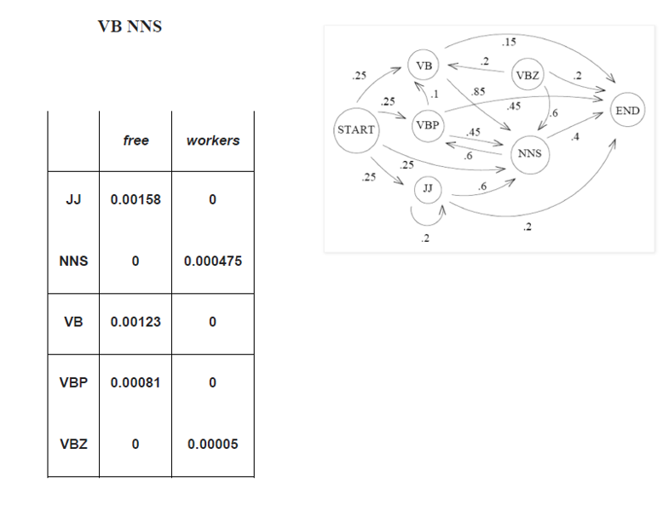
- Once a day (e.g. at noon), the weather is observed as one of state 1: rainy state 2: cloudy state 3: sunny The state transition probabilities are:
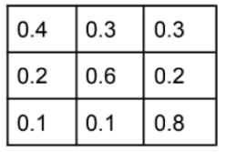
b) What is the expected number of consecutive days of sunny weather?
12. Suppose you have the input sentence “Sachin is a great cricketer”. And you know the possible tags each of the words in the sentence can take
Sachin; NN, NNS, NNP, NNPS
is: VB
a: DT
great: ADJ
cricketer: NN, NNS, NNP
How many possible hidden state sequences are possible for the above sentence and states?

UNIT-III
- Assume the following likelihoods for each word being part of a positive or negative movie review, and equal prior probabilities for each class.
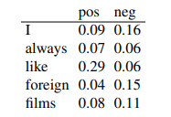
What class will Naive bayes assign to the sentence “I always like foreign films.”?

- Given the following short movie reviews, each labeled with a genre, either
comedy or action:
1. fun, couple, love, love comedy
2. fast, furious, shoot action
3. couple, fly, fast, fun, fun comedy
4. furious, shoot, shoot, fun action
5. fly, fast, shoot, love action
and a new document D:
fast, couple, shoot, fly
compute the most likely class for D. Assume a naive Bayes classifier and use
add-1 smoothing for the likelihoods.
- Train two models, multinomial naive Bayes and binarized naive Bayes, both with add-1 smoothing, on the following document counts for key sentiment words, with positive or negative class assigned as noted.
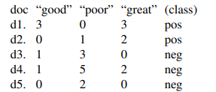
Use both naive Bayes models to assign a class (pos or neg) to this sentence: A good, good plot and great characters, but poor acting. Recall from page 61 that with naive Bayes text classification, we simply ignore (throw out) any word that never occurred in the training document. (We don’t throw out words that appear in some classes but not others; that’s what add-one smoothing is for.) Do the two models agree or disagree?

- Let’s walk through an example of training and testing naive Bayes with add-one smoothing. We’ll use a sentiment analysis domain with the two classes positive (+) and negative (-), and take the following miniature training and test documents simplified from actual movie reviews
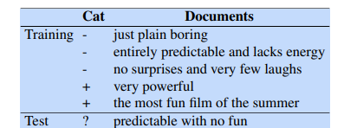

- Consider a naive Bayes model with the classes positive (+) and negative (-) and the following model parameters:
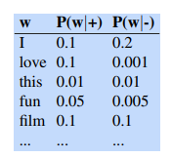
Each of the two columns above instantiates a language model that can assign a probability to the sentence “I love this fun film”: Solve it.

- Apply multinomial bayes approach for
